Project Planning Phase
Project Planning Template (Product Backlog, Sprint Planning, Stories, Story points)

Date | 26 October 2026
Team ID
Project Name | Electric Vehicle Market Performance & Insights
Maximum Marks | 8 Marks

Product Backlog, Sprint Schedule, and Estimation (4 Marks)
Use the below template to create product backlog and sprint schedule
Sprint | Functional Requirement (Epic) | User Story Number | User Story / Task | Story Points | Priority | Team Members
Sprint-1 | Data Understanding & Preparation | US-01 | As a project user, I want the supplied EV CSV dataset inspected so that its structure and scope are understood. | 3 | High | Self
Sprint-1 | Data Understanding & Preparation | US-02 | As an analyst, I want missing values and data types profiled so that data quality limitations are visible. | 3 | High | Self
Sprint-1 | Data Understanding & Preparation | US-03 | As an analyst, I want duplicate records checked so that the preparation process is documented. | 2 | Medium | Self
Sprint-1 | Data Understanding & Preparation | US-04 | As a stakeholder, I want a data dictionary for key EV fields so that chart measures are understandable. | 3 | High | Self
Sprint-1 | Project Definition & Design | US-05 | As a stakeholder, I want the project objectives and business questions documented so that the analysis has a clear scope. | 3 | High | Self
Sprint-1 | Project Definition & Design | US-06 | As a website visitor, I want a clear project overview so that I understand the purpose of the analysis. | 3 | Medium | Self
Sprint-1 | Project Definition & Design | US-07 | As a reviewer, I want dataset caveats documented so that test-data patterns are not mistaken for verified market facts. | 3 | High | Self
Sprint-2 | Tableau Visualisation Development | US-08 | As an analyst, I want manufacturer sales summarised so that recorded sales can be compared by manufacturer. | 3 | High | Self
Sprint-2 | Tableau Visualisation Development | US-09 | As an analyst, I want battery technology distribution visualised so that dataset records can be compared by battery type. | 2 | High | Self
Sprint-2 | Tableau Visualisation Development | US-10 | As an analyst, I want average driving range by manufacturer visualised so that range patterns can be explored. | 3 | High | Self
Sprint-2 | Tableau Visualisation Development | US-11 | As an analyst, I want battery capacity plotted against driving range so that their relationship can be explored. | 3 | High | Self
Sprint-2 | Tableau Visualisation Development | US-12 | As a researcher, I want vehicle records grouped by manufacturing country so that dataset geography can be explored. | 2 | Medium | Self
Sprint-2 | Tableau Visualisation Development | US-13 | As a stakeholder, I want average customer ratings by manufacturer so that available rating patterns can be compared. | 3 | Medium | Self
Sprint-2 | Tableau Visualisation Development | US-14 | As an analyst, I want average battery capacity by battery type visualised so that technology categories can be compared. | 2 | Medium | Self
Sprint-2 | Tableau Visualisation Development | US-15 | As an analyst, I want recorded annual sales grouped by model year so that year-based patterns can be reviewed. | 2 | Medium | Self
Sprint-3 | Dashboard & Interactive Analysis | US-16 | As a stakeholder, I want the eight visualisations assembled into one dashboard so that I can review the analysis in one place. | 4 | High | Self
Sprint-3 | Dashboard & Interactive Analysis | US-17 | As a dashboard user, I want a manufacturer filter so that I can focus on selected manufacturers. | 3 | High | Self
Sprint-3 | Dashboard & Interactive Analysis | US-18 | As a dashboard user, I want a model-year filter so that I can explore records by model year. | 2 | Medium | Self
Sprint-3 | Dashboard & Interactive Analysis | US-19 | As a dashboard user, I want a battery-type filter so that I can compare technology categories. | 2 | Medium | Self
Sprint-3 | Dashboard & Interactive Analysis | US-20 | As a dashboard user, I want country and vehicle-category filtering where available so that I can narrow the analysis. | 3 | Medium | Self
Sprint-3 | Dashboard & Interactive Analysis | US-21 | As a reviewer, I want chart titles, units, labels and aggregations checked so that the dashboard is interpretable. | 3 | High | Self
Sprint-3 | Dashboard & Interactive Analysis | US-22 | As a mobile visitor, I want the dashboard page to provide a full-view link so that clipped embedded charts remain accessible. | 3 | Medium | Self
Sprint-4 | Stories, Publishing & Validation | US-23 | As a stakeholder, I want a market-performance story so that manufacturer, sales and dataset patterns are presented in sequence. | 4 | High | Self
Sprint-4 | Stories, Publishing & Validation | US-24 | As a stakeholder, I want a technology and customer-insights story so that range, battery and rating patterns are explained. | 4 | High | Self
Sprint-4 | Stories, Publishing & Validation | US-25 | As a visitor, I want the Tableau dashboard embedded in the public website so that I can explore it without leaving the site. | 3 | High | Self
Sprint-4 | Stories, Publishing & Validation | US-26 | As a visitor, I want direct links to both Tableau stories so that I can open each published story. | 2 | High | Self
Sprint-4 | Stories, Publishing & Validation | US-27 | As a reviewer, I want dashboard and story links tested so that public access can be checked. | 2 | High | Self
Sprint-4 | Stories, Publishing & Validation | US-28 | As a project owner, I want the website published through GitHub Pages so that the project is publicly accessible. | 2 | High | Self
Sprint-4 | Documentation & Demonstration | US-29 | As a reviewer, I want a README and methodology notes so that the project approach and limitations are documented. | 2 | Medium | Self
Sprint-4 | Documentation & Demonstration | US-30 | As a stakeholder, I want a demonstration walkthrough so that the dashboard, stories and website can be presented. | 1 | Medium | Self

Project Tracker, Velocity & Burndown Chart: (4 Marks)
Sprint | Total Story Points | Duration | Sprint Start Date | Sprint End Date (Planned) | Story Points Completed (as on Planned End Date) | Sprint Release Date (Actual)
Sprint-1 | 20 | 6 Days | 26 Oct 2026 | 31 Oct 2026 | Not yet measured | Not yet recorded
Sprint-2 | 20 | 6 Days | 02 Nov 2026 | 07 Nov 2026 | Not yet measured | Not yet recorded
Sprint-3 | 20 | 6 Days | 09 Nov 2026 | 14 Nov 2026 | Not yet measured | Not yet recorded
Sprint-4 | 20 | 6 Days | 16 Nov 2026 | 21 Nov 2026 | Not yet measured | Not yet recorded

Velocity:
Imagine we have a 10-day sprint duration, and the velocity of the team is 20 (points per sprint). Let’s calculate the team’s average velocity (AV) per iteration unit (story points per day)


Burndown Chart:
A burn down chart is a graphical representation of work left to do versus time. It is often used in agile software development methodologies such as Scrum. However, burn down charts can be applied to any project containing measurable progress over time.

https://www.visual-paradigm.com/scrum/scrum-burndown-chart/
https://www.atlassian.com/agile/tutorials/burndown-charts

Reference:
https://www.atlassian.com/agile/project-management
https://www.atlassian.com/agile/tutorials/how-to-do-scrum-with-jira-software
https://www.atlassian.com/agile/tutorials/epics
https://www.atlassian.com/agile/tutorials/sprints
https://www.atlassian.com/agile/project-management/estimation
https://www.atlassian.com/agile/tutorials/burndown-charts

Project-specific planning notes
Project: Electric Vehicle Market Performance & Insights. Team member: Self. Team ID intentionally left blank. Planning date: 26 October 2026.
The backlog below is a proposed plan for the completed Tableau Public and GitHub Pages capstone. It is not a record of verified task completion. Planned work is grouped into four six-day sprints with 20 story points each (80 planned points total).
Technology scope: supplied ev_market_test.csv, Tableau Public (eight visualisations, one dashboard and two stories), HTML/CSS website and GitHub Pages. Snowflake, SQL database, Python pipeline, authentication and predictive modelling are not claimed as implemented.
Dataset interpretation: this is a supplied test dataset, not independently verified real-world EV market data. Annual sales are recorded annual_sales_units aggregated by selected dimension; manufacturing-country counts are vehicle records; battery-type counts are dataset records. Missing values should not be replaced with zero without justification. Chart associations do not establish causation.
Sprint dates are proposed future planning dates anchored to 26 October 2026. Actual story points completed and actual release dates are left as 'Not yet measured' / 'Not yet recorded' because no sprint execution evidence was supplied.

Completed product backlog (30 proposed user stories)
Sprint | Functional Requirement (Epic) | User Story Number | User Story / Task | Story Points | Priority | Team Members
Sprint-1 | Data Understanding & Preparation | US-01 | As a project user, I want the supplied EV CSV dataset inspected so that its structure and scope are understood. | 3 | High | Self
Sprint-1 | Data Understanding & Preparation | US-02 | As an analyst, I want missing values and data types profiled so that data quality limitations are visible. | 3 | High | Self
Sprint-1 | Data Understanding & Preparation | US-03 | As an analyst, I want duplicate records checked so that the preparation process is documented. | 2 | Medium | Self
Sprint-1 | Data Understanding & Preparation | US-04 | As a stakeholder, I want a data dictionary for key EV fields so that chart measures are understandable. | 3 | High | Self
Sprint-1 | Project Definition & Design | US-05 | As a stakeholder, I want the project objectives and business questions documented so that the analysis has a clear scope. | 3 | High | Self
Sprint-1 | Project Definition & Design | US-06 | As a website visitor, I want a clear project overview so that I understand the purpose of the analysis. | 3 | Medium | Self
Sprint-1 | Project Definition & Design | US-07 | As a reviewer, I want dataset caveats documented so that test-data patterns are not mistaken for verified market facts. | 3 | High | Self
Sprint-2 | Tableau Visualisation Development | US-08 | As an analyst, I want manufacturer sales summarised so that recorded sales can be compared by manufacturer. | 3 | High | Self
Sprint-2 | Tableau Visualisation Development | US-09 | As an analyst, I want battery technology distribution visualised so that dataset records can be compared by battery type. | 2 | High | Self
Sprint-2 | Tableau Visualisation Development | US-10 | As an analyst, I want average driving range by manufacturer visualised so that range patterns can be explored. | 3 | High | Self
Sprint-2 | Tableau Visualisation Development | US-11 | As an analyst, I want battery capacity plotted against driving range so that their relationship can be explored. | 3 | High | Self
Sprint-2 | Tableau Visualisation Development | US-12 | As a researcher, I want vehicle records grouped by manufacturing country so that dataset geography can be explored. | 2 | Medium | Self
Sprint-2 | Tableau Visualisation Development | US-13 | As a stakeholder, I want average customer ratings by manufacturer so that available rating patterns can be compared. | 3 | Medium | Self
Sprint-2 | Tableau Visualisation Development | US-14 | As an analyst, I want average battery capacity by battery type visualised so that technology categories can be compared. | 2 | Medium | Self
Sprint-2 | Tableau Visualisation Development | US-15 | As an analyst, I want recorded annual sales grouped by model year so that year-based patterns can be reviewed. | 2 | Medium | Self
Sprint-3 | Dashboard & Interactive Analysis | US-16 | As a stakeholder, I want the eight visualisations assembled into one dashboard so that I can review the analysis in one place. | 4 | High | Self
Sprint-3 | Dashboard & Interactive Analysis | US-17 | As a dashboard user, I want a manufacturer filter so that I can focus on selected manufacturers. | 3 | High | Self
Sprint-3 | Dashboard & Interactive Analysis | US-18 | As a dashboard user, I want a model-year filter so that I can explore records by model year. | 2 | Medium | Self
Sprint-3 | Dashboard & Interactive Analysis | US-19 | As a dashboard user, I want a battery-type filter so that I can compare technology categories. | 2 | Medium | Self
Sprint-3 | Dashboard & Interactive Analysis | US-20 | As a dashboard user, I want country and vehicle-category filtering where available so that I can narrow the analysis. | 3 | Medium | Self
Sprint-3 | Dashboard & Interactive Analysis | US-21 | As a reviewer, I want chart titles, units, labels and aggregations checked so that the dashboard is interpretable. | 3 | High | Self
Sprint-3 | Dashboard & Interactive Analysis | US-22 | As a mobile visitor, I want the dashboard page to provide a full-view link so that clipped embedded charts remain accessible. | 3 | Medium | Self
Sprint-4 | Stories, Publishing & Validation | US-23 | As a stakeholder, I want a market-performance story so that manufacturer, sales and dataset patterns are presented in sequence. | 4 | High | Self
Sprint-4 | Stories, Publishing & Validation | US-24 | As a stakeholder, I want a technology and customer-insights story so that range, battery and rating patterns are explained. | 4 | High | Self
Sprint-4 | Stories, Publishing & Validation | US-25 | As a visitor, I want the Tableau dashboard embedded in the public website so that I can explore it without leaving the site. | 3 | High | Self
Sprint-4 | Stories, Publishing & Validation | US-26 | As a visitor, I want direct links to both Tableau stories so that I can open each published story. | 2 | High | Self
Sprint-4 | Stories, Publishing & Validation | US-27 | As a reviewer, I want dashboard and story links tested so that public access can be checked. | 2 | High | Self
Sprint-4 | Stories, Publishing & Validation | US-28 | As a project owner, I want the website published through GitHub Pages so that the project is publicly accessible. | 2 | High | Self
Sprint-4 | Documentation & Demonstration | US-29 | As a reviewer, I want a README and methodology notes so that the project approach and limitations are documented. | 2 | Medium | Self
Sprint-4 | Documentation & Demonstration | US-30 | As a stakeholder, I want a demonstration walkthrough so that the dashboard, stories and website can be presented. | 1 | Medium | Self

Velocity calculation
Planned average velocity per working day = planned story points per sprint ÷ sprint duration = 20 ÷ 6 = 3.33 story points per working day. This is a planning estimate based on the template's 20-point sprint assumption, not measured team velocity.

Burndown chart
The following is an illustrative ideal burndown for 80 planned story points over 24 working days. Replace it with actual daily remaining-work data when sprint tracking is available.
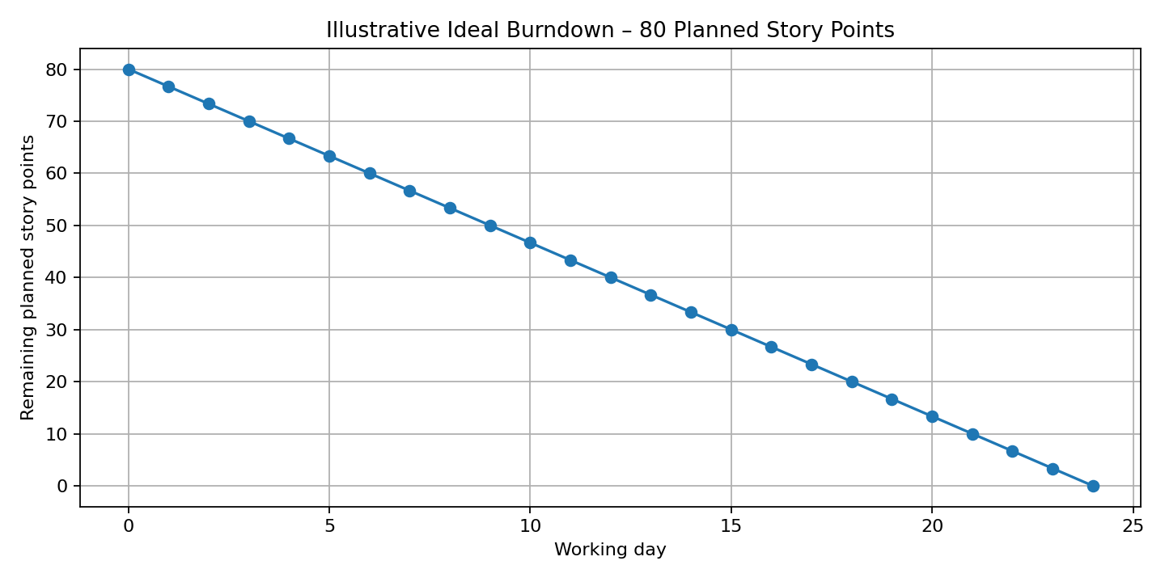
References retained from the template: Atlassian Agile Project Management and Scrum resources; Visual Paradigm Scrum Burndown Chart.

